Wilmar Union
Citizens Oversight Annual Report
Period Ending June 30, 2017
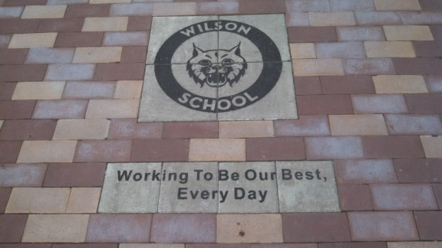

BEFORE
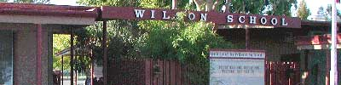

AFTER
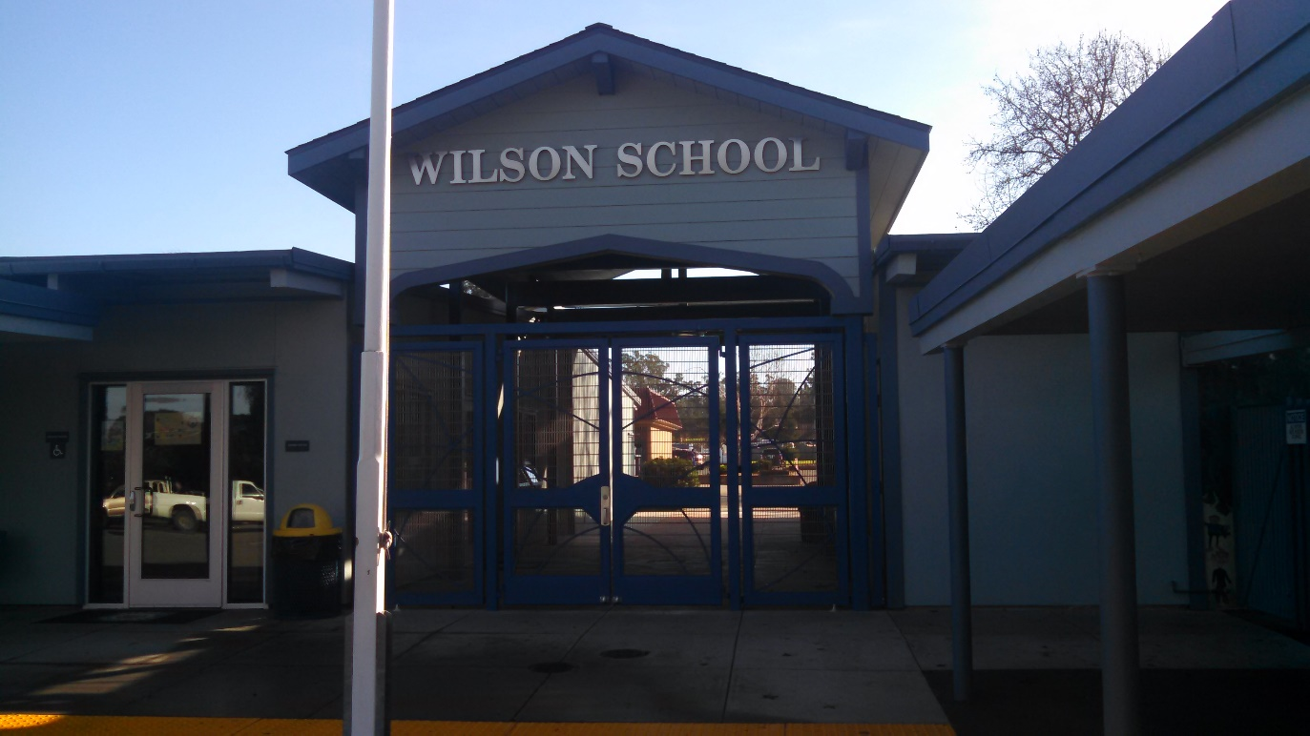

The WILMAR UNION SCHOOL DISTRICT CITIZENS’ BOND OVERSIGHT COMMITTEE respectfully submits this report to WILMAR UNION SCHOOL DISTRICT BOARD OF EDUCATION on April 13, 2017 as directed by the Citizens’ Bond Oversight Committee BYLAWS:

We confirm that as a committee we have accomplished the tasks set forth in Section 3 of our Citizens’ Bond Oversight Bylaws.

Section 3.
Duties. To carry out its stated purposes, the Committee shall perform the following duties:

3.1 Inform the Public. The Committee shall inform the public concerning the District’s expenditures of bond proceeds.

3.2 Review Expenditures. The Committee may review quarterly expenditure reports produced by the District to ensure that (a) bond proceeds are expended only for the purposes set forth in the ballot measure; (b) no bond proceeds are used for any teacher or administrative salaries or other operating expenses.

HISTORY:

On November 6, 2012, the voters of the Wilmar Union School district approved, by more than 55%, Measure P, authorizing the issuance and sale of General Obligation Bonds in an aggregate principal amount not to exceed $4,000,000. The first series was issued on April 18, 2013 in the aggregate principal amount of $2,000,000. The second series was issued on November 12, 2014 in the aggregate principal amount of $1,997,456. The bonds were issued to provide funds to finance a multi-year project which included construction and school facilities improvements.

The total outstanding bond indebtedness as of June 30, 2015 is $3,982,436.

Measure P bonds are Proposition 39 bonds, issued by Wilmar Union School District. The passage of proposition 39 in November 2000 amended the California Constitution to include accountability provisions. Specifically, the District must conduct annual independent performance audit to ensure that funds have been expended only by specific projects listed as well as an annual, independent financial audit of proceeds from sale of bonds until all proceeds have been expended for facilities projects.

Upon Passage of Proposition 39, an accompanying piece of legislation, AB 1908 (Chapter 44, Statutes of 2000), was also enacted, which amended the Education Code to establish additional procedures which must be followed if a District seeks approval of a bond proposition pursuant to 55% majority authorized in Proposition 39 including the formation, composition and purpose of the Citizens’ Bond Oversight Committee, and authorization for injunctive relief against the improper expenditure of bond revenues.

Citizens’ Bond Oversight Committee:

Name | Affiliation | Term End
Brian Breen | Business Organization | October 2017
Al Mello | Senior Citizens Organization | October 2018
Dan Drummond | Sonoma County Taxpayers Association | October 2017
Renee Waters | Parent | October 2018
Stacey Lakritz | Parent/PTA member | October 2017
Linda Blue | At Large | October 2018
Vacant | At Large | October 2018

Projects completed with G.O. Bond Series A funds

Phase 1 Series A Projects List completed in Summer 2013
- Computer lab replaced with all new iMac computers
- Short throw projection systems for all classrooms to support Common Core instruction
- Perimeter fencing added for student safety
- Wi-Fi upgrade

New Computers for the Technology Lab: Classroom Projection system:
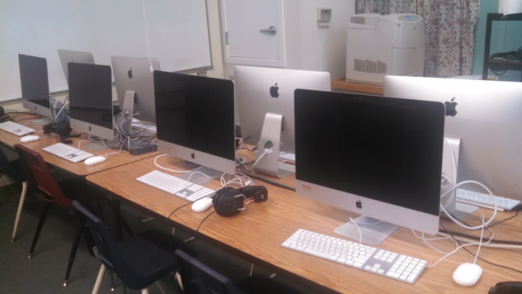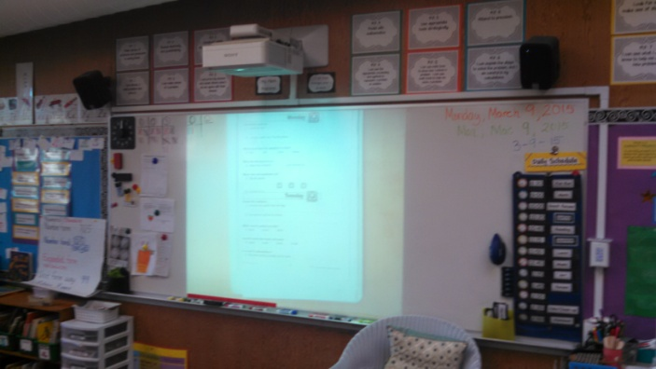

Perimeter fencing:
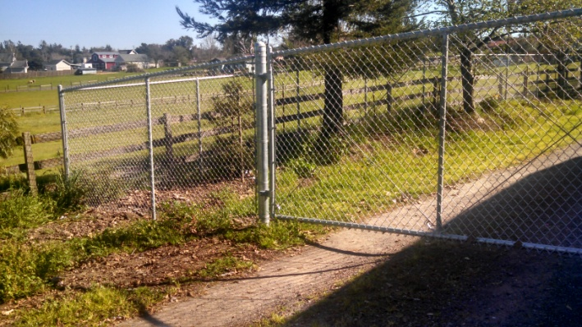

Phase 1 Series A Projects List completed in Summer 2014
- Louvered Windows in classrooms replaced
- Office expanded and complete remodel
- Sewer line from between buildings and out to septic tank replaced
- Removed trees between buildings (courtyard)
- Replaced courtyard with new brick entry way and logo
- New front Wildcat entrance gates
- Upper grade bathrooms completely remodeled
- ADA path of travel updates

New Heat Efficient Windows New Wildcat Entry Gates
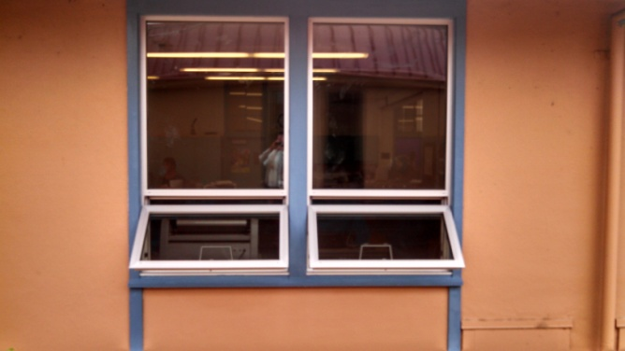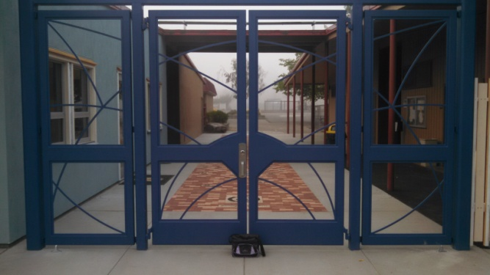

New Office Lobby Area Beautiful New Student Bathrooms
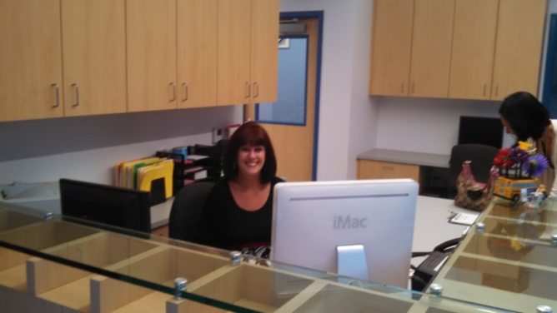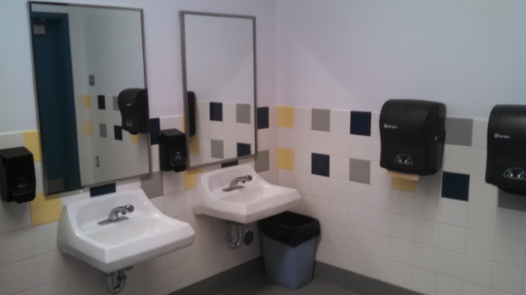

PHASE 2 Series B Projects List completed in Summer of 2015
- Building B addition – Staff Workroom-Upper cabinets, mail boxes, Custodian and Storage area.
- Courtyard Canopy Steel Columns and Roof Added
- Permanent dry rot mitigation on East end of Building A and Building B roof eaves.
- All Classrooms in Buildings A and B:
  - New acoustic ceiling panels
  - New window shades
  - New skylight shades
  - New carpet (excluding rooms K, 1, 8)
  - New VCT at sink cabinets (excluding rooms K, 1, 8)
  - New wall base (excluding rooms B1, B8, B9)
  - New paint (field and accent wall)
  - New tackable wall panels
  - New whiteboards (2 – 4’-0” x 12’-0”)
  - Existing casework repaired and painted
  - New sinks and countertops in existing casework
- Corridor A:
  - New VCT flooring to match corridor B
  - New wall base
  - New tackable wall panels
  - New paint on walls above tack board and ceiling
- Corridor B:
  - (e) flooring to remain
  - New wall base
  - New tackable wall panels
  - New paint on walls above tack board and ceiling
- Restrooms Building B (Primary Bathrooms, Kindergarten bathrooms):
  - New plumbing fixtures – relocated to meet current accessibility code
  - New finishes – epoxy floor and base, tile wainscot, paint
  - New partitions and accessories

- Cluster Building C –
  - New hot water heater system
- Move 4th grade to room 10, install wall panels
- Air conditioning for classrooms
- Install automated gates at rear entrance
- New Wall between Room 4 and 5
- Replace classroom lighting with LED fixtures in A building (Prop 39)
- Drinking fountain in Kindergarten playground
- Paint main buildings
- New Sign at back entrance

Kindergarten Bathroom before New Kindergarten Bathroom
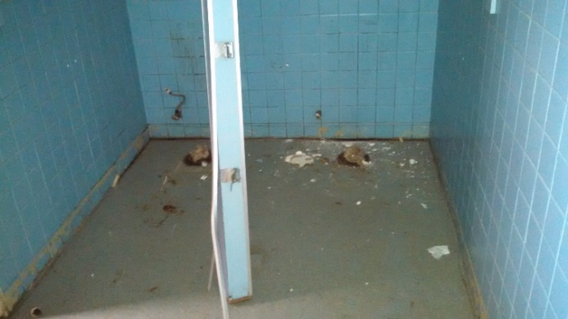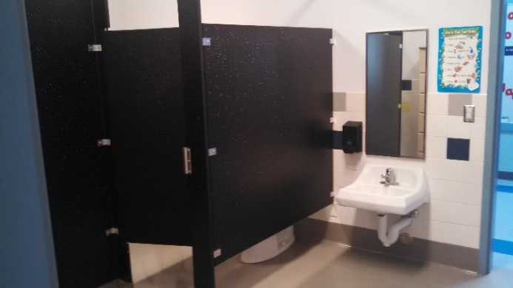

Classrooms with new carpet, new tack board walls, new paint and refurbished cabinets.
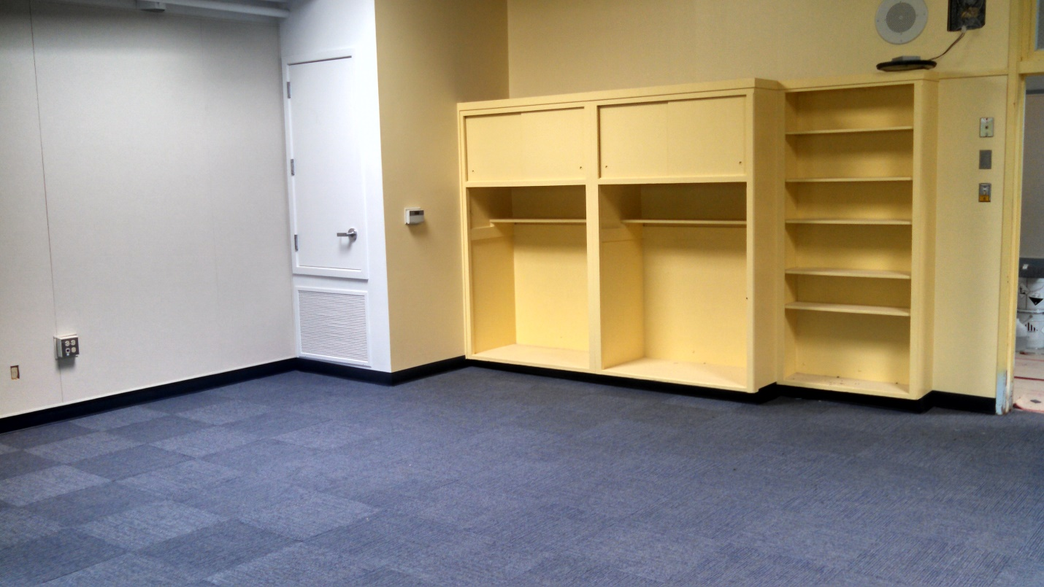

Dry rot removal under eves. New roof to replace dry rot areas.
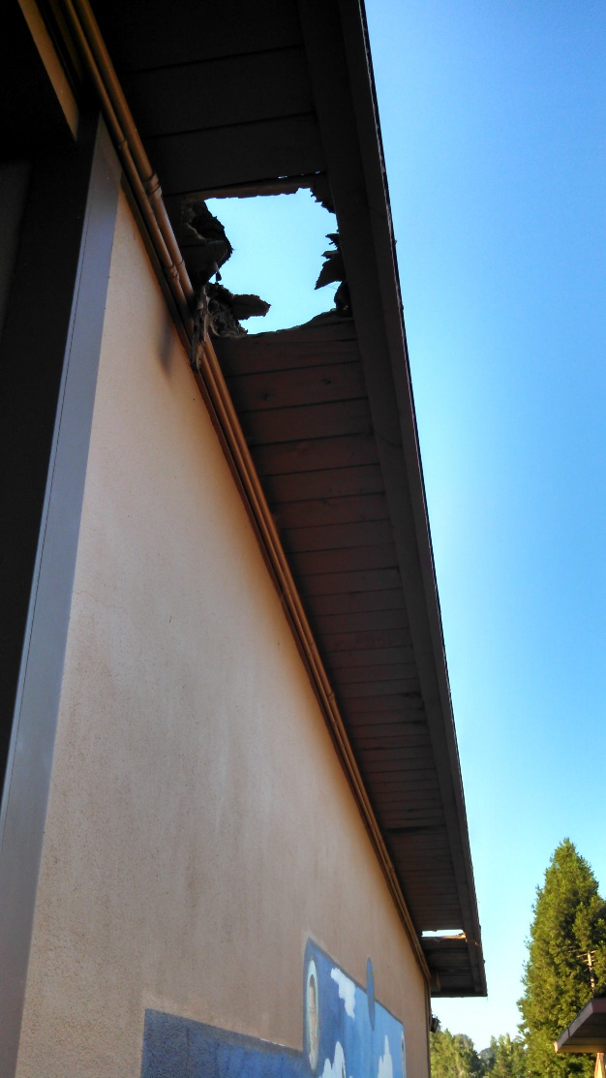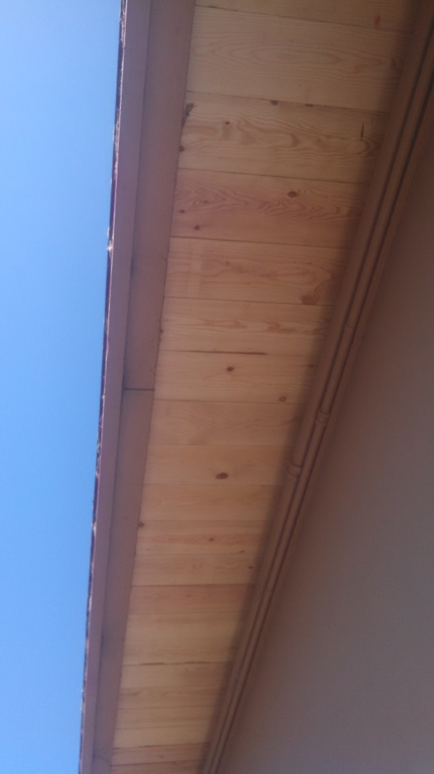

Air conditioner units for all classrooms.
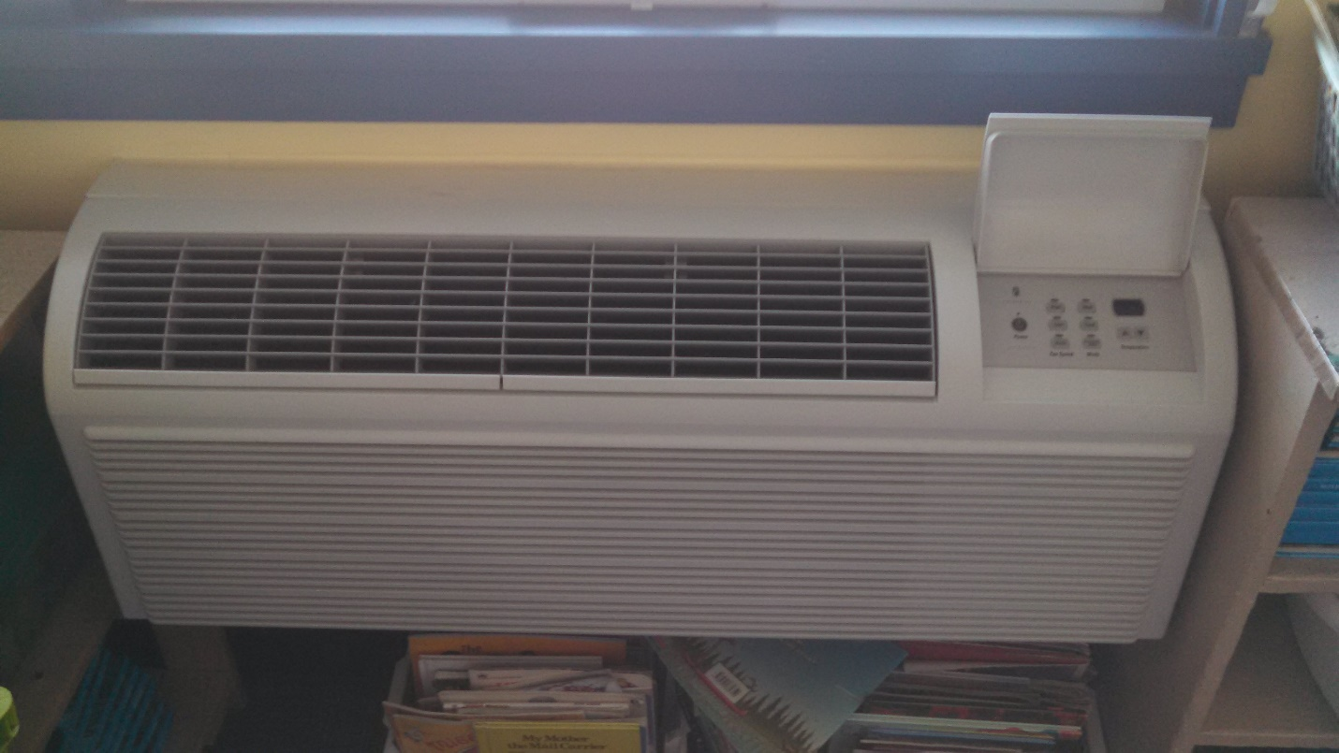

Remodeled Primary Boys Bathroom.
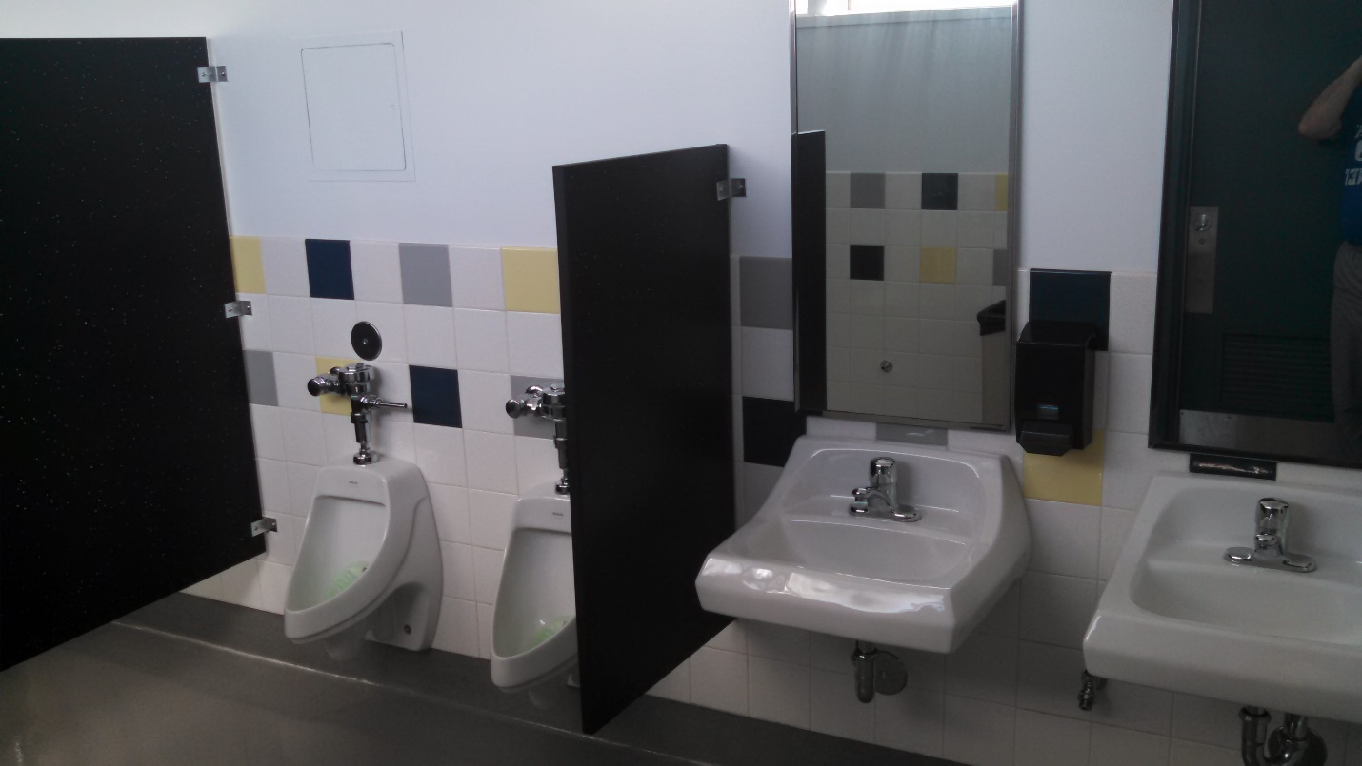

New Staff Workroom.
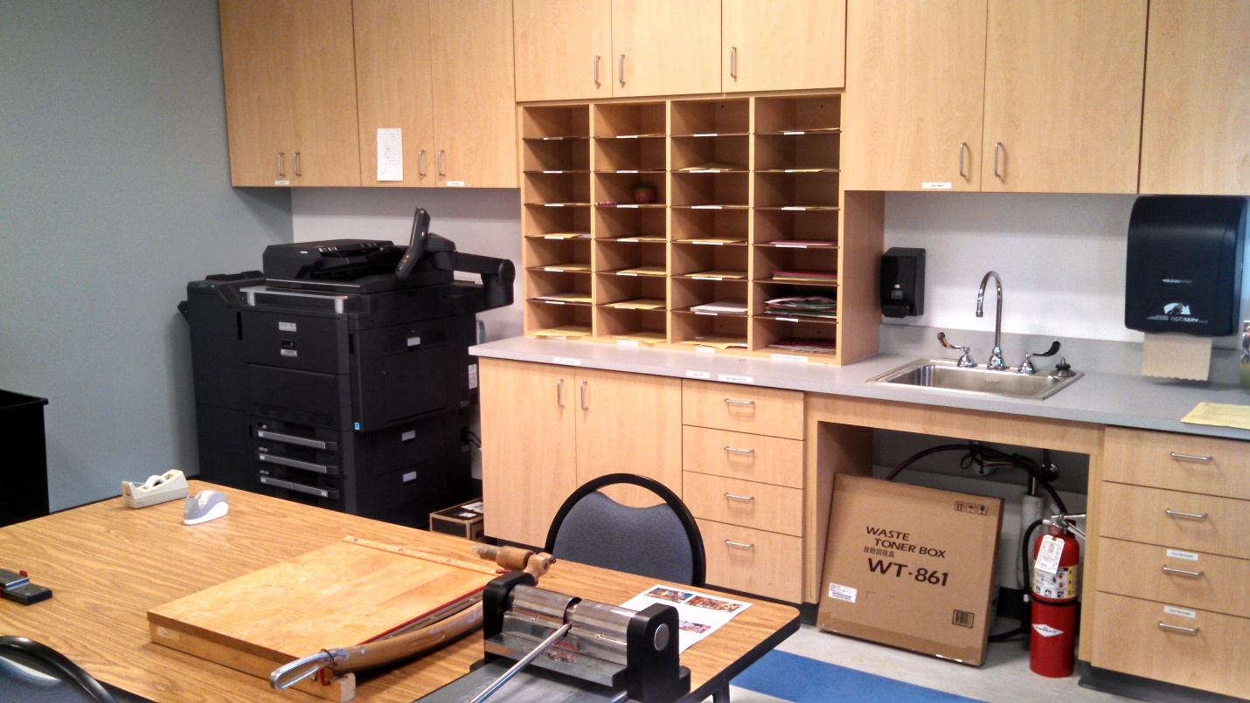

Automated Back Gate and New Back Entrance Sign.
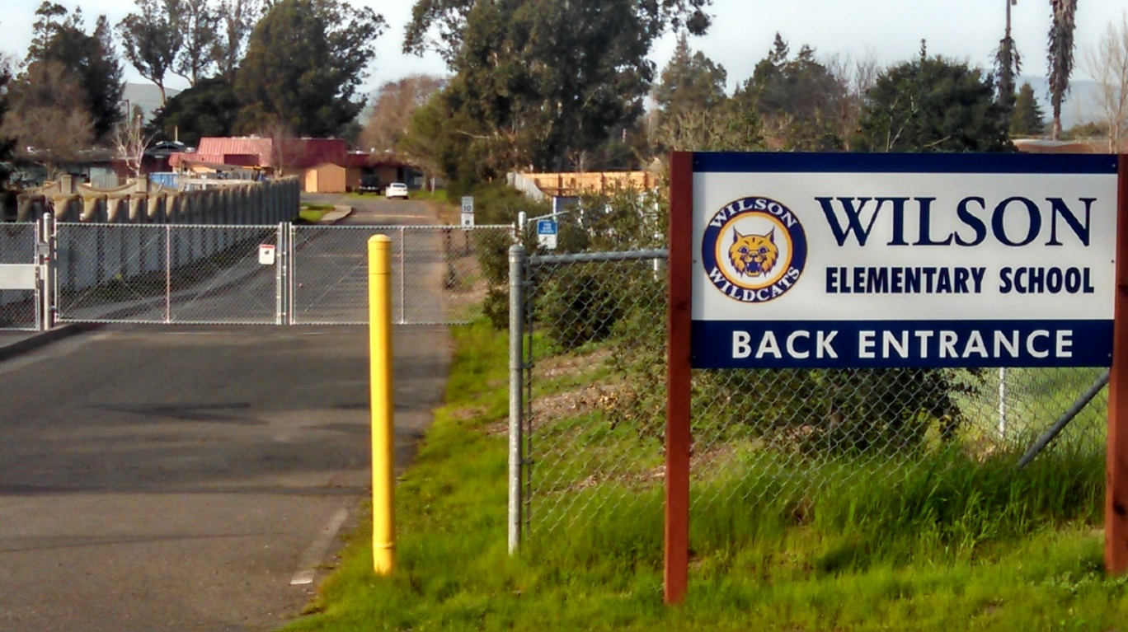

Roof repair above Primary Bathrooms
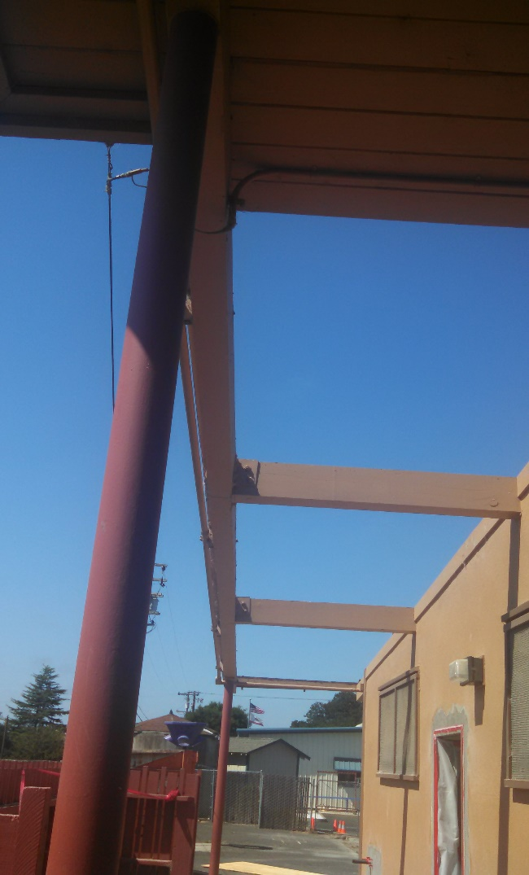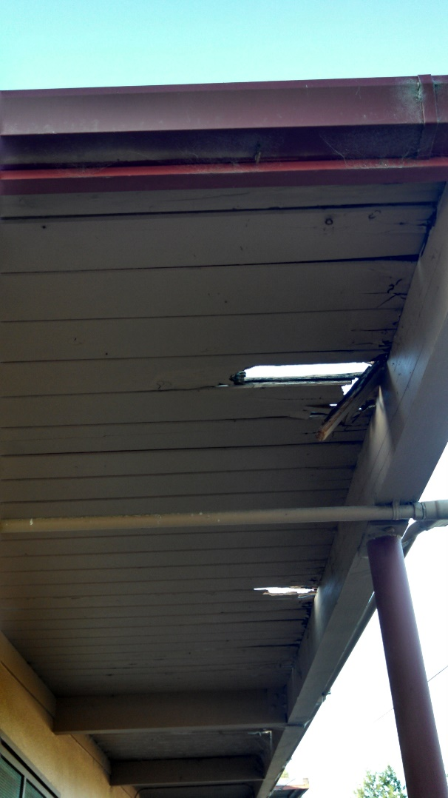

PHASE 2 Series B Projects List completed from summer 2015 through March 2017
- Roll-Up Kitchen window and kitchen equipment upgrades
- Emergency Sewer Repairs-leach field lines cleaned and distribution boxes cleaned and fitted with new metal box covers.
- Back parking lot expanded to increase safety and the number of parking spaces.
- Repairs made to all blacktop areas, playgrounds and parking lots.
- All blacktop areas sealed and restriped
- New roofs installed on Portables 2 and 3.

Back parking lot expansion.
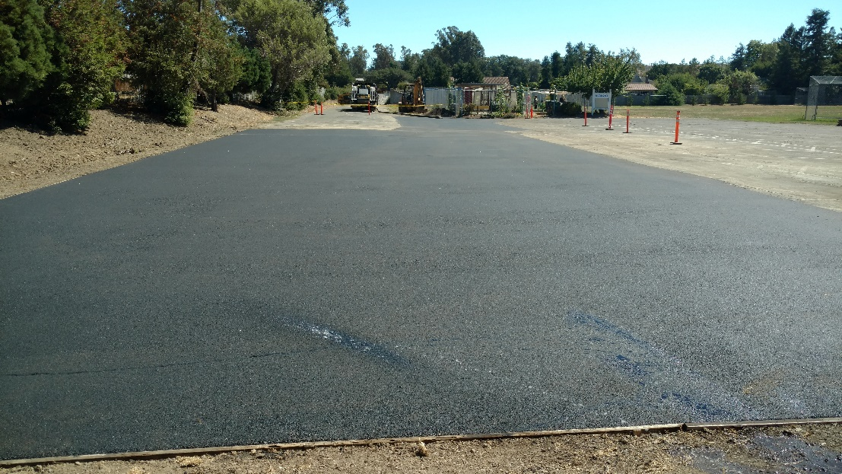

Upper Playground new striping.
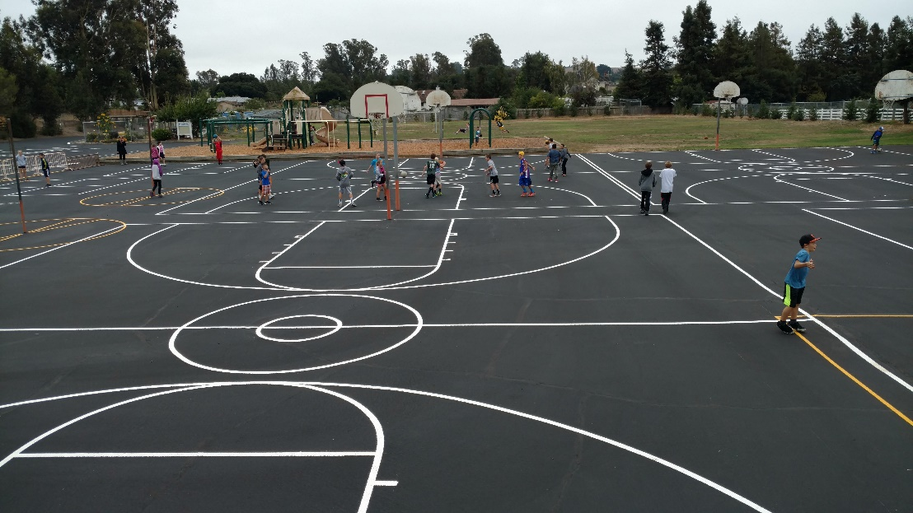

Front Parking Lot new striping.
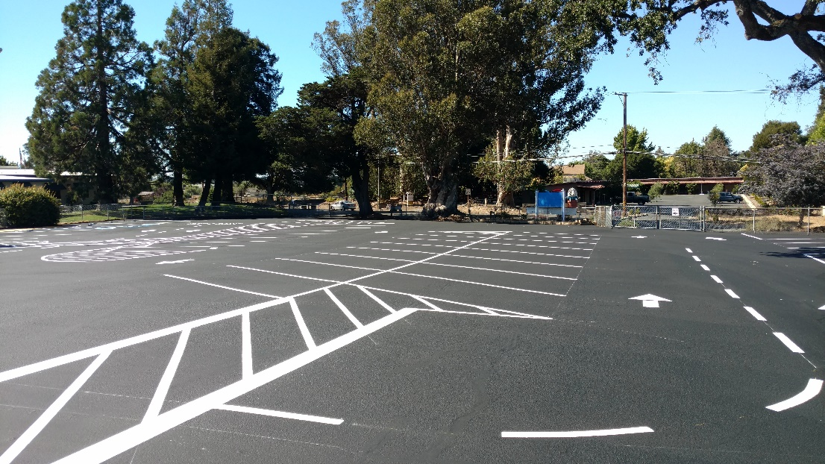

New Roll-Up Window in Cluster Kitchen.
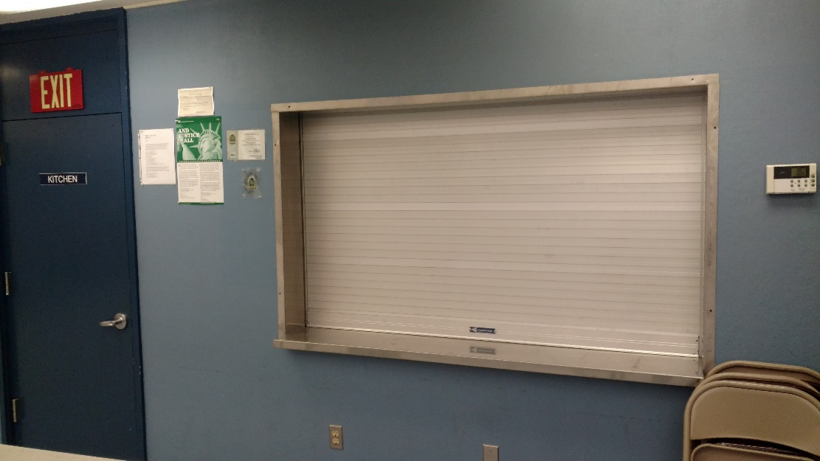

New Sink, Tables, Range and Mural for Cluster Kitchen.
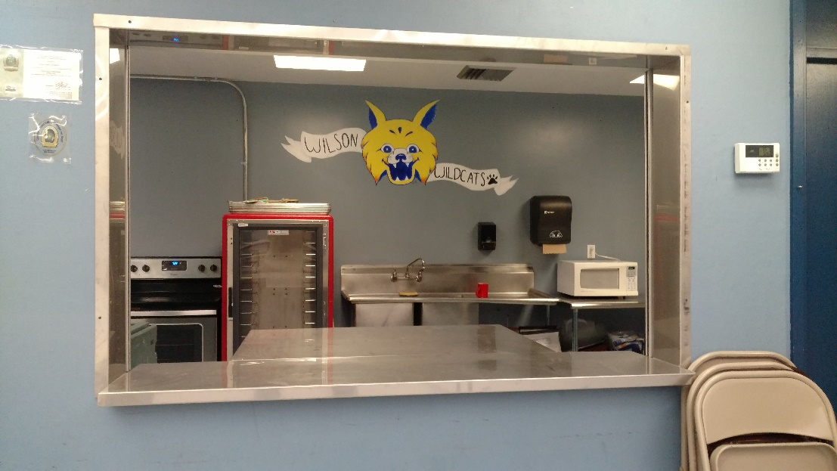
Wilmar USD G.O. Bond Expenditure Summary Series A & B
(See attached Exhibit A)
The expenditure report was prepared and submitted by Business Manager, Jolene Hale,
Wilmar Union School District.

Expenditures since Last Report Given on January 2016. (See attached report.)
The expenditure report was prepared and submitted by Business Manager, Jolene Hale,
Wilmar Union School District and shows all expenditures since January 2016.

Independent Auditor’s Report Year Ending June 30, 2016.
(See attached Audit Report)
The bond performance audit was performed by Goodell, Porter, Sanchez & Bright, LLP for period ending June 30, 2016. There were no findings and the Wilmar Union District was found to be in compliance with Measure P Bond Fund spending requirements.

The Citizens’ Oversight Bond Committee met on the following dates to review bond progress, expenditures and the Auditor’s Report.

August 25, 2015 October 5, 2015 January 27, 2016 February 7, 2017

Annual Bond Oversight Report
This report was prepared by Linda Blue, Chairperson Citizens’ Bond Oversight Committee with assistance from Eric Hoppes, Superintendent and Jolene Hale, Business Manager. This report is created to meet Oversight requirements, but also to document the process and progress that has been made on fulfilling the promises made to voters. The previous pages show how much the school has changed to create a safe, functional and beautiful campus for students, parents, staff and the Wilson School community.

In closing, it is the opinion of the Committee that the Wilmar Union School District has expended the bond money appropriately as identified on the Measure P Bond Ballot. At this date all Measure P Bonds have been expended this is the Citizens Oversight Final Report. A Bond Audit for the year ending June 30, 2017 will be submitted to the Board when it is completed.

Respectively submitted,

Linda Blue
Chairperson
Citizen’s Bond and Oversight Committee

